**УО «Белорусский государственный университет информатики и радиоэлектроники»**

**Кафедра ПОИТ**

**Отчёт по лабораторной работе №2.4**

**По предмету**

**Основы алгоритмизации и программирования**

**Вариант 6**

**Выполнил:**

**Гладкий М.Г.**

**Проверила:**

**Данилова Г.В.**

**Группа 851001**

**Минск 2018**

**Задание:**

Дана действительная квадратная матрица порядка 2n. Цифрами обозначены  
подматрицы порядка n.

|  |  |
| --- | --- |
| 1 | 2 |
| 3 | 4 |

Получить новую матрицу:

|  |  |
| --- | --- |
| 4 | 3 |
| 1 | 2 |

**Код Delphi 10:**

**program** Project8;

{$APPTYPE CONSOLE}

**uses**

SysUtils;

**type**

TArray = **array**[0..255,0..255] **of** Real;

**const**

MinSize = 1;

MaxSize = 128;

MinInt: Integer = -2147483646;

MaxInt: Integer = 2147483647;

**procedure** ChangeMatrix(Size: Byte; **var** Matrix: TArray);

**var**

i, j: Byte;

Bufer: Real;

Num: Byte;

**begin**

Num := Size **div** 2;

**for** i := 0 **to** Num **do**

**for** j := 0 **to** Size **do**

**begin**

Bufer := Matrix[i][j];

Matrix[i][j] := Matrix[i + Num + 1][j];

Matrix[i + Num + 1][j] := Bufer;

**end**;

**for** i := 0 **to** Num **do**

**for** j := 0 **to** Num **do**

**begin**

Bufer := Matrix[i][j];

Matrix[i][j] := Matrix[i][Num + j + 1];

Matrix[i][Num + j + 1] := Bufer;

**end**;

**end**;

**function** ChoiceInput(): Char;

**var**

Input: Char;

IsCorrect: Boolean;

**begin**

**repeat**

Readln(Input);

Input := UpCase(Input);

**if** (Input = 'Y')**or**(Input = 'N') **then**

IsCorrect := true

**else**

**begin**

IsCorrect := false;

Write('Incorrect input. Enter Y(Yes) or N(No): ');

**end**;

**until** IsCorrect;

ChoiceInput := Input;

**end**;

**procedure** OutputConsole(Size: Byte; **var** Matrix: TArray);

**var**

i, j: Byte;

**begin**

Writeln('Matrix:');

**for** i := 0 **to** Size **do**

**begin**

**for** j := 0 **to** Size **do**

Write(Matrix[i][j]:5:2,' ');

Writeln;

**end**;

**end**;

**procedure** ShowMatrixFile(**var** NewFile: TextFile; Size: Byte; **var** Matrix: TArray);

**var**

i, j: Byte;

**begin**

Writeln(NewFile, 'Matrix:');

**for** i := 0 **to** Size **do**

**begin**

**for** j := 0 **to** Size **do**

Write(NewFile, Matrix[i][j]:5:2,' ');

Writeln(NewFile);

**end**;

**end**;

**procedure** OutputFile(Size: Byte; **var** Matrix: TArray);

**var**

IsCorrect: Boolean;

NewFile: TextFile;

NameOfFile: String;

**begin**

Write('Enter the name of file (.txt): ');

IsCorrect := false;

**repeat**

Readln(NameOfFile);

**if** (**not** FileExists(NameOfFile)) **then**

Write('File does not exist. Try again: ')

**else**

**begin**

IsCorrect := true;

Assign(NewFile, NameOfFile);

Write('Would you like to rewrite the file? Enter Y(Yes) or N(No): ');

**if** ChoiceInput = 'Y' **then**

**try**

Rewrite(NewFile);

ShowMatrixFile(NewFile, Size, Matrix);

**except**

Write('Access is not allowed. Try again: ');

IsCorrect:= false;

**end**

**else**

**try**

Append(NewFile);

ShowMatrixFile(NewFile, Size, Matrix);

**except**

Write('Access is not allowed. Try again: ');

IsCorrect:= false;

**end**;

**end**;

**until** IsCorrect;

Close(NewFile);

**end**;

**function** CheckInput(Min, Max: Integer): Real;

**var**

Number: Real;

IsCorrect: Boolean;

**begin**

IsCorrect := false;

**repeat**

**try**

Readln(Number);

**if** (Number >= Min) **and** (Number <= Max) **then**

IsCorrect := true

**else**

Writeln('Enter number from interval [', Min, '..', Max, ']: ');

**except**

Writeln('Check entered data. Enter number from interval [', Min, '..',

Max, ']: ');

**end**;

**until** IsCorrect;

CheckInput := Number;

**end**;

**function** CheckSize(Min, Max: Integer): Byte;

**var**

Size: Byte;

IsCorrect: Boolean;

**begin**

IsCorrect := false;

**repeat**

**try**

Readln(Size);

**if** (Size >= Min) **and** (Size <= Max) **then**

IsCorrect := true

**else**

Writeln('Enter number from interval [', Min, '..', Max, ']: ');

**except**

Writeln('Check entered data. Enter number from interval [', Min, '..',

Max, ']: ');

**end**;

**until** IsCorrect;

CheckSize := Size;

**end**;

**procedure** GetDataConsole(**var** Size: Byte; **var** Matrix: TArray);

**var**

i, j: Byte;

**begin**

Write('Enter size of submatrix[', MinSize,'..', MaxSize,'].Your matrix will

have size 2 times bigger than this: ');

Size := CheckSize(MinSize, MaxSize);

Size := (Size * 2) - 1;

Writeln('Enter your matrix: ');

**for** i := 0 **to** Size **do**

**for** j := 0 **to** Size **do**

**begin**

Write('Element[',i + 1,'][',j + 1,'] = ');

Matrix[i][j] := CheckInput(MinInt, MaxInt);

**end**;

**end**;

**function** CheckInputFile(Min, Max: Integer; **var** MyFile: TextFile): Boolean;

**var**

IsCorrect: Boolean;

Number: Integer;

**begin**

IsCorrect := true;

**while** (**not** SeekEof(MyFile)) **and** (IsCorrect) **do**

**try**

Readln(MyFile, Number);

**if** (Number <= Min) **or** (Number >= Max) **then**

IsCorrect := false;

**except**

IsCorrect := false;

**end**;

CheckInputFile := IsCorrect;

**end**;

**function** ReadFromFile(**var** MyFile: TextFile; **var** Size: Byte; **var** Matrix: TArray):

Boolean;

**var**

i, j: Byte;

**begin**

**if** CheckInputFile(MinInt, MaxInt, MyFile) **then**

**begin**

reset(MyFile);

i := 0;

**while not** Eof(MyFile) **do**

**begin**

j := 0;

**while not** Eoln(MyFile) **do**

**begin**

Read(MyFile, Matrix[i][j]);

inc(j);

**end**;

Readln(MyFile);

inc(i);

**end**;

**if** i = j **then**

**begin**

Size := i - 1;

ReadFromFile := true;

**end**

**else**

**begin**

Writeln('This is not square matrix. Try again.');

ReadFromFile := false;

**end**;

**end**

**else**

**begin**

CloseFile(MyFile);

ReadFromFile := false;

Write('Check entered data. Enter number from interval ', MinInt, '..',

MaxInt, '. Try Again: ');

**end**;

**end**;

**procedure** GetDataFile(**var** Size: Byte; **var** Matrix: TArray);

**var**

IsCorrect: Boolean;

NameOfFile: String;

MyFile: TextFile;

**begin**

Write('Enter file name(.txt): ');

**repeat**

Readln(NameOfFile);

**if** (**not** FileExists(NameOfFile)) **then**

**begin**

WriteLn('File does not exist. Try again: ');

IsCorrect := false;

**end**

**else**

**begin**

AssignFile(MyFile, NameOfFile);

reset(MyFile);

**if** SeekEof(MyFile) **then**

**begin**

Writeln('File is empty. Try again: ');

IsCorrect := false;

**end**

**else**

IsCorrect := ReadFromFile(MyFile, Size, Matrix);

**end**;

**until** IsCorrect;

CloseFile(MyFile);

**end**;

**procedure** Main();

**var**

Matrix: TArray;

Size: Byte;

**begin**

Writeln('This program changes entered Matrix is such way: 1 2 3 4 => 4 3 1

2');

Write('Would you like to use File input instead of Console input? Enter Y(Yes)

or N(No): ');

**if** ChoiceInput = 'Y' **then**

GetDataFile(Size, Matrix)

**else**

GetDataConsole(Size, Matrix);

OutputConsole(Size, Matrix);

ChangeMatrix(Size, Matrix);

Write('Would you like to write down the answer to File instead of Console?

Enter Y(Yes) or N(No): ');

**if** ChoiceInput = 'Y' **then**

OutputFile(Size, Matrix)

**else**

OutputConsole(Size, Matrix);

Writeln('Press "Enter" to exit.');

Readln;

**end**;

**begin**

Main;

**end.**

**Скриншоты:**

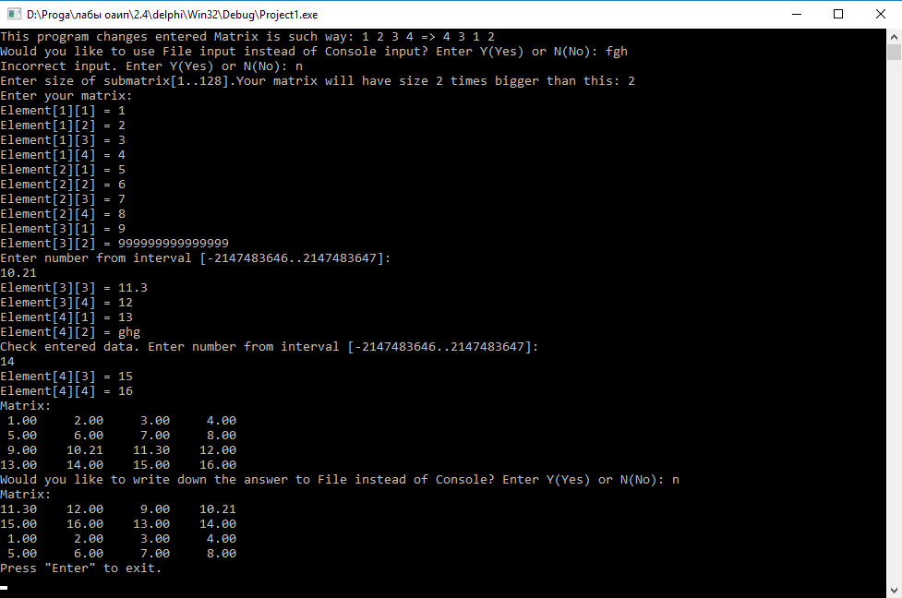

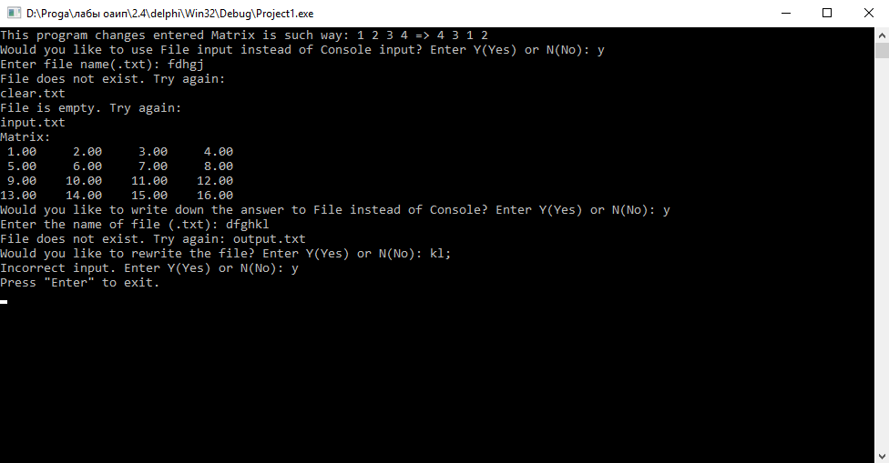

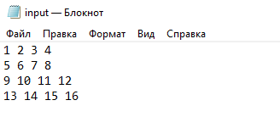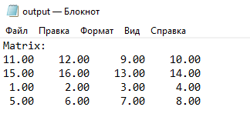

**Блок-схема:**







